|  |  |
| --- | --- |
|  | 🞂济南大学ESI学科分析报告 |
|  |  |
|  | 🞂 🞂 2015-09-14 |
|  |  |
|  |  |
|  |  |
|  |  |
|  |  |
|  |  |
|  |  |
|  |  |
|  |  |
|  |  |



为了深入了解济南大学优势学科的发展情况，本报告基于Web of Science和Incites的客观数据，对济南大学进入全球机构前1%的学科及潜力学科做了分析。由于ESI将所有科研成果以22类学科划分，这与我国《中华人民共和国学科分类与代码国家标准》（标准号“GB/T 13745-92”）以及国务院学位委员会、教育部颁布的《学位授予和人才培养学科目录（2011年）》等学科分类标准存在较大差异，所以，为了深入了解本机构具体哪些学科、哪些人、哪些期刊及文章对进入全球前1%的ESI学科做出贡献，报告将对其展开分析工作。（本报告中所有ESI数据均来源于2015年09月01日更新的内容。）

**一、济南大学ESI学科现状分析**

为了加强整体学科规划与发展，挖掘我校有潜力进入ESI的学科也是十分必要的。济南大学从2005-今，科研高产出的学科分布在生物学与生物化学、化学、临床医学、工程学、材料科学、数学、物理学等学科，如图-1所示。

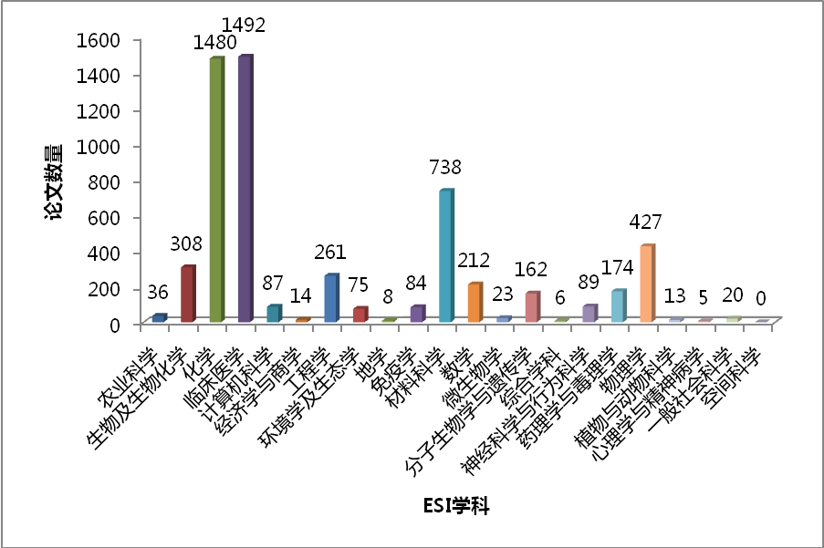

图-1 济南大学各学科的科研产出(2005-今)

被引频次直接反应了各个学科在全球范围内的影响力，可以看到济南大学在生物学与生物化学、化学、临床医学、工程学、材料科学、分子生物学与遗传学、药理学与毒理学、物理学等学科有一定的影响力，如图-2。

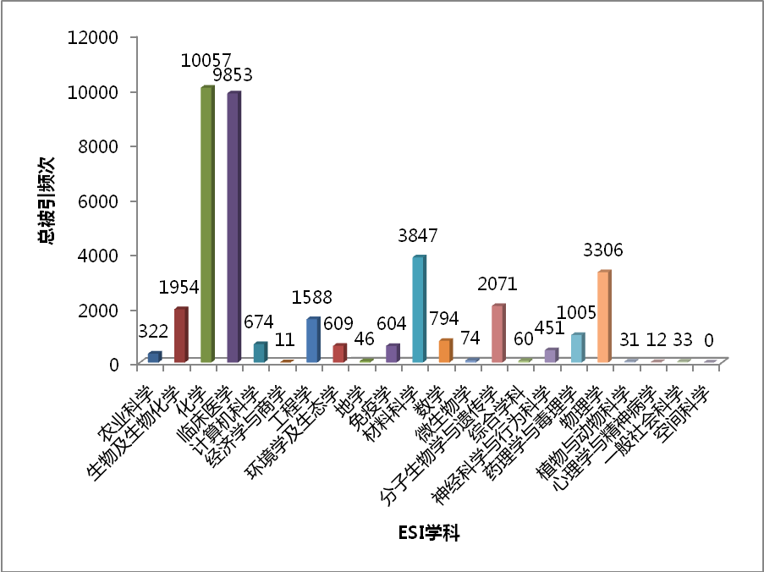

图-2 济南大学各学科的论文的总被引频次(2005-今)

二、济南大学有潜力进入ESI前1%的学科

为了挖掘我校有潜力进入ESI的学科，报告选取了济南大学各学科的总被引频次和门槛值[1]并做了比对分析，如图-3。比值越接近1说明越有可能进入全球前1%。可以看到除了已经进入前1%的临床医学、化学和材料科学之外，工程学也比较接近于阈值。由于工程学科和计算机学科的总别引频次部分来自于Web of Science中收录的会议录，并不直接计入ESI统计，所以其结果比ESI真实值略高。

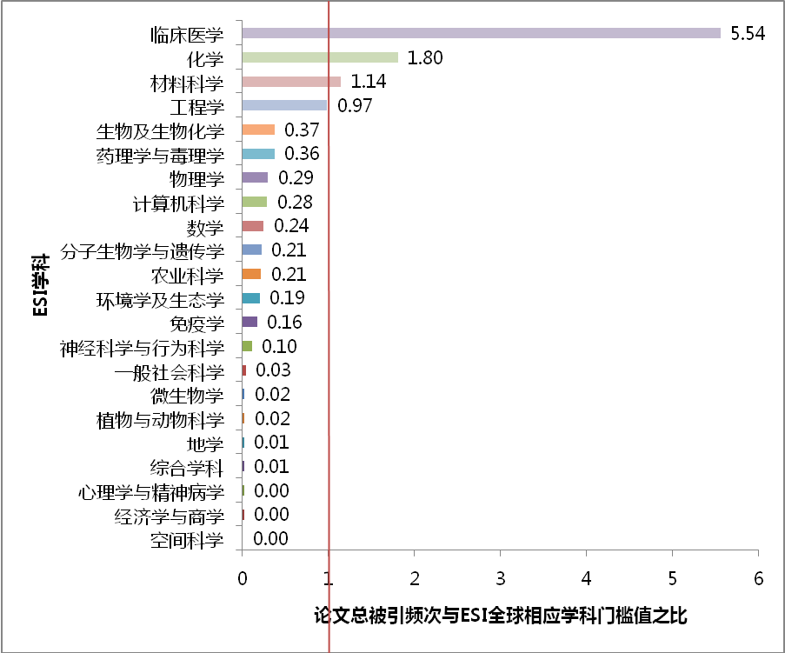

图-3 济南大学ESI学科趋势预测

三、济南大学高质量论文概况

ESI高质量论文 (Top Papers) 共分为两种，高频被引论文（Highly Cited Papers）和热点论文（Hot Papers）。高频被引论文指近十年发表的被SCI或SSCI收录的Article或Review，其总被引频次在相应学科处在全球范围内的前**百分之一**；热点论文指近两年发表的被SCI或SSCI收录的Article或Review，其总被引频次在近两个月处在相应学科全球范围内的前**千分之一**。

根据ESI2015年09月01日统计结果，我校共有36篇论文成为高频被引论文（包含山东省医学科学院及附属医院）。他们分布在临床医学、材料科学、化学、物理学、工程学、生物学与生物化学、环境与生态科学、数学这八个学科中。其中被引频次最高的是山东省医学科学院ZHANG, Furen老师于2009年发表在*NEW ENGLAND JOURNAL OF MEDICINE*上的论文“Genomewide Association Study of Leprosy”，截止至今在Web of Science中总被引用258次。

四、山东省ESI学科及高质量论文对比

在2015年09月01日的统计数据中，山东省共有10所高校共计38个学科进入了ESI全球前1%，具体情况如表-1所示。

表-1 2015年09月山东省ESI学科概况

|  |  |  |  |
| --- | --- | --- | --- |
| **高校名称** | **ESI学科数量** | **高被引论文数量** | **热点论文数量** |
| 山东大学 | 13 | 223 | 8 |
| 中国海洋大学 | 9 | 76 | 4 |
| 中国石油大学 | 3 | 49 | 1 |
| 济南大学 | 3 | 36 | 1 |
| 青岛科技大学 | 2 | 20 | 1 |
| 青岛大学 | 2 | 52 | 0 |
| 山东农业大学 | 2 | 15 | 0 |
| 山东师范大学 | 1 | 14 | 0 |
| 聊城大学 | 1 | 15 | 0 |
| 曲阜师范大学 | 1 | 31 | 0 |

五、济南大学材料科学学科分析

材料科学2015年9月国内高校ESI排名如下表所示。可以看到排在前10位的科研机构分别是清华大学、上海交通大学、浙江大学、复旦大学、哈尔滨工业大学、吉林大学、北京大学、中国科学技术大学、中南大学和北京科技大学。在下表中，排名第一的清华大学至排名第七十一的河南大学，其材料科学学科进入了ESI的前1%行列。我校的材料科学学科按照ESI总被引频次排在国内高校的第68位，省内高校第5位。

表-2 ESI材料科学国内高校排名

|  |  |  |  |  |  |  |
| --- | --- | --- | --- | --- | --- | --- |
| 排名 | 机构名称 | 论文数量 | 学科相对影响力 | 总被引频次 | 论文被引用百分率 | 国际合作论文数 |
| 1 | Tsinghua University | 6894 | 1.27 | 83969 | 75 | 1230 |
| 2 | Shanghai Jiao Tong University | 5428 | 1.19 | 56504 | 79 | 1064 |
| 3 | Zhejiang University | 4639 | 1.3 | 54473 | 81 | 859 |
| 4 | Fudan University | 2403 | 2.45 | 48958 | 87 | 559 |
| 5 | Harbin Institute of Technology | 7155 | 0.76 | 48606 | 73 | 1100 |
| 6 | Jilin University | 3698 | 1.28 | 42791 | 81 | 523 |
| 7 | Peking University | 2457 | 1.87 | 37441 | 82 | 523 |
| 8 | University of Science & Technology of China | 2708 | 1.72 | 37049 | 83 | 408 |
| 9 | Central South University | 5861 | 0.64 | 31839 | 72 | 739 |
| 10 | University of Science & Technology Beijing | 5731 | 0.59 | 29640 | 67 | 876 |
| 11 | Nanjing University | 2268 | 1.49 | 28604 | 82 | 350 |
| 12 | South China University of Technology | 3293 | 1.16 | 28502 | 74 | 584 |
| 13 | Tianjin University | 3200 | 1.03 | 27430 | 74 | 491 |
| 14 | Dalian University of Technology | 3505 | 0.89 | 26960 | 76 | 686 |
| 15 | Sichuan University | 3339 | 1.02 | 26879 | 74 | 415 |
| 16 | Xi'an Jiaotong University | 3665 | 0.88 | 25688 | 73 | 700 |
| 17 | Shandong University | 3000 | 1 | 25682 | 76 | 452 |
| 18 | Huazhong University of Science & Technology | 2965 | 1.15 | 24819 | 74 | 434 |
| 19 | Northwestern Polytechnical University | 4671 | 0.64 | 24127 | 69 | 499 |
| 20 | Wuhan University | 1737 | 1.49 | 21866 | 79 | 290 |
| 21 | Nankai University | 1057 | 2.22 | 20624 | 85 | 174 |
| 22 | Wuhan University of Technology | 2900 | 0.87 | 20418 | 69 | 576 |
| 23 | Suzhou University | 1719 | 2.07 | 19961 | 78 | 430 |
| 24 | Sun Yat Sen University | 1349 | 1.81 | 18848 | 81 | 258 |
| 25 | Beihang University | 2847 | 0.87 | 18643 | 70 | 429 |
| 26 | East China University of Science & Technology | 1583 | 1.4 | 18472 | 80 | 342 |
| 27 | Beijing University of Chemical Technology | 1588 | 1.48 | 17916 | 83 | 250 |
| 28 | Tongji University | 2067 | 1.02 | 17099 | 75 | 439 |
| 29 | Southeast University - China | 2015 | 1.07 | 16949 | 76 | 417 |
| 30 | Lanzhou University | 1407 | 1.3 | 16123 | 84 | 160 |
| 31 | Shanghai University | 2162 | 0.83 | 15568 | 73 | 395 |
| 32 | Northeastern University - China | 3338 | 0.52 | 14622 | 66 | 721 |
| 33 | Donghua University | 1789 | 1.03 | 13882 | 74 | 393 |
| 34 | Hunan University | 1668 | 1.03 | 13827 | 72 | 222 |
| 35 | Xiamen University | 1203 | 1.52 | 13254 | 79 | 335 |
| 36 | Nanjing University of Aeronautics & Astronautics | 1680 | 0.95 | 13226 | 74 | 252 |
| 37 | Chongqing University | 2483 | 0.74 | 12370 | 64 | 446 |
| 38 | Beijing Institute of Technology | 1459 | 1.23 | 11637 | 71 | 272 |
| 39 | Harbin Engineering University | 972 | 1.35 | 10507 | 73 | 84 |
| 40 | Nanjing University of Technology | 1354 | 1.01 | 9876 | 74 | 246 |
| 41 | Beijing University of Technology | 1386 | 0.71 | 9025 | 69 | 201 |
| 42 | Northeast Normal University - China | 522 | 1.78 | 8995 | 86 | 37 |
| 43 | East China Normal University | 645 | 1.59 | 8438 | 82 | 133 |
| 44 | Fuzhou University | 666 | 1.8 | 8181 | 75 | 91 |
| 45 | Nanjing University of Science & Technology | 1085 | 1.22 | 8162 | 73 | 215 |
| 46 | Jiangsu University | 1256 | 0.88 | 7570 | 69 | 123 |
| 47 | Central China Normal University | 310 | 2.17 | 7405 | 85 | 40 |
| 48 | University of Electronic Science & Technology of China | 1266 | 0.7 | 7104 | 71 | 256 |
| 49 | Southwest Jiaotong University | 954 | 0.84 | 7012 | 73 | 208 |
| 50 | Hefei University of Technology | 854 | 1.01 | 6825 | 73 | 125 |
| 51 | China University of Petroleum | 859 | 1.13 | 6464 | 67 | 167 |
| 52 | Xiangtan University | 855 | 0.89 | 5756 | 79 | 140 |
| 53 | Yanshan University | 1266 | 0.6 | 5697 | 70 | 182 |
| 54 | Zhengzhou University | 882 | 0.9 | 5395 | 70 | 127 |
| 55 | Shaanxi Normal University | 612 | 0.97 | 4974 | 78 | 78 |
| 56 | Beijing Jiaotong University | 638 | 0.88 | 4932 | 71 | 111 |
| 57 | Qingdao University of Science & Technology | 550 | 1.01 | 4738 | 77 | 83 |
| 58 | Zhejiang Sci-Tech University | 555 | 1.05 | 4557 | 76 | 99 |
| 59 | Ocean University of China | 456 | 1.17 | 4509 | 80 | 52 |
| 60 | Nanjing University of Posts & Telecommunications | 253 | 2.65 | 4389 | 76 | 64 |
| 61 | Shanghai Normal University | 310 | 1.6 | 4361 | 85 | 35 |
| 62 | Fourth Military Medical University | 344 | 1.32 | 4296 | 81 | 64 |
| 63 | Beijing Normal University | 416 | 1.28 | 4243 | 75 | 60 |
| 64 | China University of Geosciences | 867 | 0.93 | 4227 | 66 | 131 |
| 65 | Taiyuan University of Technology | 1165 | 0.62 | 4205 | 61 | 146 |
| 66 | Zhejiang University of Technology | 643 | 0.86 | 4105 | 68 | 111 |
| 67 | Hubei University | 486 | 1.09 | 3870 | 70 | 116 |
| **68** | **University of Jinan** | **738** | **0.75** | **3847** | **67** | **99** |
| 69 | Anhui University | 498 | 1.14 | 3726 | 74 | 60 |
| 70 | Zhejiang Normal University | 417 | 1.48 | 3726 | 75 | 63 |
| 71 | Henan University | 552 | 0.98 | 3699 | 78 | 56 |
| 72 | Heilongjiang University | 323 | 1.48 | 3554 | 78 | 28 |
| 73 | Anhui University of Technology | 548 | 1 | 3541 | 71 | 75 |
| 74 | National University of Defence Technology - China | 796 | 0.66 | 3519 | 63 | 68 |
| 75 | Guangxi University | 755 | 0.61 | 3441 | 72 | 83 |
| 76 | Kunming University of Science & Technology | 950 | 0.55 | 3359 | 59 | 113 |
| 77 | Wuhan University of Science & Technology | 743 | 0.54 | 3237 | 59 | 91 |
| 78 | Southwest University - China | 410 | 1.27 | 3220 | 74 | 67 |
| 79 | Jinan University | 432 | 1.12 | 3193 | 75 | 41 |
| 80 | Hebei University of Technology | 608 | 0.68 | 3035 | 65 | 71 |
| 81 | Lanzhou University of Technology | 587 | 0.63 | 2935 | 65 | 40 |
| 82 | Yangzhou University | 336 | 1.04 | 2909 | 76 | 50 |
| 83 | Huaqiao University | 321 | 1.17 | 2892 | 72 | 32 |
| 84 | Jiangnan University | 648 | 0.63 | 2862 | 62 | 102 |
| 85 | Nanchang University | 538 | 0.86 | 2839 | 71 | 49 |
| 86 | Shenzhen University | 623 | 0.68 | 2832 | 65 | 74 |
| 87 | Shantou University | 142 | 1.47 | 2734 | 91 | 18 |
| 88 | Yunnan University | 231 | 1.27 | 2719 | 71 | 38 |
| 89 | China University of Mining & Technology | 699 | 0.61 | 2656 | 59 | 100 |
| 90 | Shaanxi University of Science & Technology | 766 | 0.56 | 2587 | 62 | 39 |
| 91 | Anhui Normal University | 192 | 1.37 | 2517 | 83 | 10 |
| 92 | South China Normal University | 346 | 1.07 | 2513 | 72 | 47 |
| 93 | Fujian Normal University | 282 | 1 | 2475 | 79 | 25 |
| 94 | Ningbo University | 453 | 0.87 | 2382 | 71 | 69 |
| 95 | Changchun University of Science & Technology | 357 | 0.94 | 2336 | 68 | 24 |
| 96 | Xinjiang University | 296 | 0.9 | 2324 | 66 | 40 |
| 97 | Guangdong University of Technology | 584 | 0.67 | 2322 | 61 | 70 |
| 98 | Nanjing Normal University | 282 | 1.42 | 2284 | 78 | 24 |
| 99 | Northwest University Xi'an | 315 | 1.3 | 2251 | 67 | 56 |
| 100 | Tianjin University of Technology | 281 | 1.06 | 2233 | 74 | 34 |

我校材料科学共有3篇高被引论文，如下图所示：

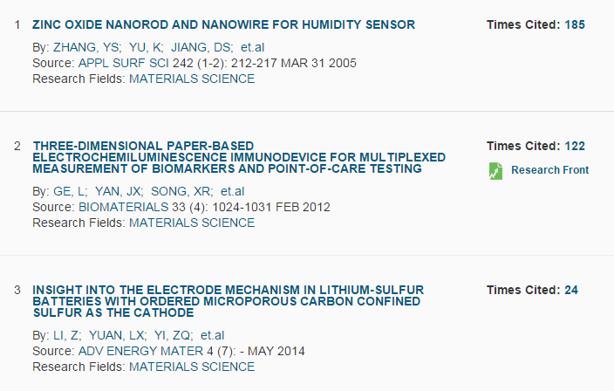

图-4 济南大学材料学科高被引论文

六、济南大学临床医学学科分析

临床医学2015年9月国内高校ESI排名如下表所示。可以看到排在前10位的科研机构分别是上海交通大学、北京大学、中山大学、复旦大学、浙江大学、首都医科大学、四川大学、华中科技大学、第二军医大学和南京医科大学。在下表中，排名第一的上海交通大学至排名第五十九的湖南师范大学，其临床医学学科都进入了ESI的前1%行列。我校的临床医学学科按照ESI总被引频次排在国内高校的第29位，省内高校第2位。

表-6 ESI临床医学国内高校排名

|  |  |  |  |  |  |  |
| --- | --- | --- | --- | --- | --- | --- |
| 排名 | 机构名称 | 论文数量 | 学科相对影响力 | 总被引频次 | 论文被引用百分率 | 国际合作论文数 |
| 1 | Shanghai Jiao Tong University | 11373 | 1.09 | 103044 | 74 | 2660 |
| 2 | Peking University | 7387 | 1.1 | 77712 | 76 | 2249 |
| 3 | Sun Yat Sen University | 8408 | 1.06 | 77220 | 77 | 1908 |
| 4 | Fudan University | 8224 | 1.09 | 73269 | 75 | 2115 |
| 5 | Zhejiang University | 6475 | 0.85 | 47240 | 72 | 1237 |
| 6 | Capital Medical University | 6261 | 0.88 | 43338 | 69 | 1585 |
| 7 | Sichuan University | 6086 | 0.74 | 39918 | 72 | 1097 |
| 8 | Huazhong University of Science & Technology | 5425 | 0.82 | 36751 | 75 | 1277 |
| 9 | Second Military Medical University | 3982 | 1.01 | 35154 | 76 | 701 |
| 10 | Nanjing Medical University | 4783 | 1.05 | 34313 | 73 | 909 |
| 11 | Fourth Military Medical University | 3679 | 0.99 | 31575 | 79 | 793 |
| 12 | Shandong University | 4720 | 0.86 | 30486 | 71 | 1047 |
| 13 | Central South University | 3883 | 0.95 | 28005 | 70 | 808 |
| 14 | China Medical University | 3745 | 0.81 | 24063 | 72 | 765 |
| 15 | Nanjing University | 2723 | 1.06 | 21980 | 75 | 552 |
| 16 | Third Military Medical University | 2826 | 0.89 | 21722 | 74 | 516 |
| 17 | Harbin Medical University | 2703 | 0.95 | 19991 | 74 | 655 |
| 18 | Wuhan University | 2923 | 0.84 | 19542 | 73 | 578 |
| 19 | Shanghai Institutes for Biological Sciences | 1088 | 1.67 | 18238 | 86 | 408 |
| 20 | Southern Medical University - China | 2766 | 0.97 | 18018 | 70 | 532 |
| 21 | Tianjin Medical University | 2402 | 0.97 | 17562 | 71 | 629 |
| 22 | Xi'an Jiaotong University | 2465 | 0.84 | 16593 | 72 | 604 |
| 23 | Tongji University | 2484 | 1.02 | 16217 | 68 | 575 |
| 24 | Suzhou University | 2377 | 0.96 | 15244 | 69 | 478 |
| 25 | Chongqing Medical University | 2204 | 0.97 | 13897 | 71 | 457 |
| 26 | Wenzhou Medical University | 1964 | 0.78 | 11557 | 67 | 549 |
| 27 | Anhui Medical University | 1666 | 0.86 | 11129 | 71 | 347 |
| 28 | Jilin University | 2039 | 0.82 | 10955 | 64 | 588 |
| **29** | **University of Jinan** | **1492** | **0.79** | **9853** | **69** | **225** |
| 30 | Tsinghua University | 948 | 1.12 | 9569 | 75 | 271 |
| 31 | Guangzhou Medical University | 1494 | 0.96 | 9553 | 70 | 283 |
| 32 | Southeast University - China | 1342 | 1.09 | 9205 | 70 | 312 |
| 33 | Zhengzhou University | 1819 | 0.76 | 9180 | 64 | 401 |
| 34 | Fujian Medical University | 1308 | 0.75 | 7689 | 67 | 236 |
| 35 | Guangxi Medical University | 1225 | 0.95 | 7635 | 71 | 185 |
| 36 | Hebei Medical University | 1195 | 0.8 | 7537 | 69 | 221 |
| 37 | Jinan University | 992 | 0.79 | 6779 | 70 | 186 |
| 38 | Dalian Medical University | 939 | 0.92 | 6660 | 67 | 236 |
| 39 | Shantou University | 688 | 1.04 | 6468 | 74 | 152 |
| 40 | Xiamen University | 954 | 0.95 | 5973 | 68 | 271 |
| 41 | Qingdao University | 1138 | 0.68 | 5780 | 65 | 170 |
| 42 | Nantong University | 873 | 0.78 | 4859 | 69 | 107 |
| 43 | Nankai University | 476 | 1.08 | 4482 | 78 | 172 |
| 44 | Lanzhou University | 631 | 0.84 | 4250 | 71 | 144 |
| 45 | Jiangsu University | 670 | 0.87 | 3755 | 69 | 65 |
| 46 | University of Science & Technology of China | 285 | 1.66 | 3452 | 78 | 123 |
| 47 | Nanchang University | 679 | 0.78 | 3306 | 65 | 130 |
| 48 | Shanghai University of Traditional Chinese Medicine | 699 | 0.74 | 3187 | 66 | 183 |
| 49 | Shanxi Medical University | 438 | 0.78 | 2911 | 73 | 125 |
| 50 | China Pharmaceutical University | 316 | 1.03 | 2726 | 77 | 85 |
| 51 | Kunming Medical University | 555 | 0.86 | 2631 | 69 | 161 |
| 52 | Yanbian University | 284 | 0.83 | 2533 | 76 | 204 |
| 53 | East China Normal University | 240 | 1.19 | 2405 | 78 | 109 |
| 54 | Xinjiang Medical University | 553 | 0.69 | 2342 | 60 | 112 |
| 55 | Ningbo University | 286 | 1.2 | 2127 | 69 | 63 |
| 56 | Shanghai University | 172 | 1.18 | 2050 | 80 | 47 |
| 57 | Beijing University of Chinese Medicine | 553 | 0.53 | 2011 | 61 | 178 |
| 58 | Xuzhou Medical College | 493 | 0.75 | 1971 | 63 | 68 |
| 59 | Hunan Normal University | 247 | 0.72 | 1913 | 77 | 122 |
| 60 | Beijing Normal University | 194 | 0.81 | 1824 | 74 | 76 |
| 61 | Shenyang Pharmaceutical University | 150 | 1.08 | 1791 | 80 | 47 |
| 62 | South China Normal University | 141 | 0.93 | 1557 | 83 | 35 |
| 63 | Ningxia Medical University | 297 | 0.81 | 1508 | 65 | 56 |
| 64 | Shenzhen University | 235 | 1.05 | 1434 | 61 | 68 |
| 65 | China Agricultural University | 135 | 0.96 | 1422 | 76 | 62 |
| 66 | Chongqing University | 175 | 0.99 | 1396 | 79 | 89 |
| 67 | Yangzhou University | 311 | 0.79 | 1396 | 66 | 56 |
| 68 | Harbin Institute of Technology | 183 | 0.78 | 1253 | 73 | 68 |
| 69 | Kunming Institute of Zoology | 120 | 0.9 | 1214 | 83 | 41 |
| 70 | Hangzhou Normal University | 199 | 0.9 | 1143 | 64 | 66 |
| 71 | Tianjin University | 181 | 0.71 | 1132 | 73 | 62 |
| 72 | Nanjing Normal University | 114 | 1.15 | 1111 | 79 | 18 |
| 73 | Ocean University of China | 101 | 1.28 | 1063 | 79 | 21 |
| 74 | Inner Mongolia Medical University | 243 | 0.77 | 1062 | 62 | 59 |
| 75 | Zhejiang Chinese Medical University | 280 | 0.7 | 1057 | 55 | 58 |
| 76 | Zhejiang Sci-Tech University | 96 | 1.14 | 1031 | 85 | 28 |
| 77 | Liaoning Medical University | 247 | 0.69 | 1029 | 62 | 23 |
| 78 | South China University of Technology | 114 | 1.16 | 1015 | 74 | 32 |
| 79 | East China University of Science & Technology | 109 | 0.91 | 899 | 70 | 26 |
| 80 | Beihang University | 190 | 0.62 | 881 | 71 | 36 |
| 81 | Northwest University Xi'an | 137 | 0.72 | 866 | 69 | 28 |
| 82 | Dalian University of Technology | 139 | 0.72 | 837 | 74 | 32 |
| 83 | Shaanxi Normal University | 120 | 0.68 | 798 | 78 | 19 |
| 84 | Heilongjiang University of Chinese Medicine | 139 | 0.98 | 759 | 73 | 46 |
| 85 | Henan University | 141 | 0.7 | 685 | 62 | 28 |
| 86 | Xidian University | 105 | 0.99 | 673 | 73 | 32 |
| 87 | Shihezi University | 165 | 0.64 | 665 | 62 | 35 |
| 88 | Beijing University of Technology | 155 | 0.57 | 661 | 70 | 23 |
| 89 | Northeast Normal University - China | 79 | 1.16 | 651 | 85 | 21 |
| 90 | Shandong University of Traditional Chinese Medicine | 196 | 0.55 | 650 | 56 | 33 |
| 91 | University of Electronic Science & Technology of China | 105 | 0.78 | 647 | 60 | 44 |
| 92 | Northwest A&F University - China | 82 | 1.11 | 644 | 76 | 33 |
| 93 | Southwest University - China | 66 | 1.37 | 638 | 67 | 26 |
| 94 | Henan University of Science & Technology | 185 | 0.65 | 636 | 55 | 10 |
| 95 | Fujian Normal University | 101 | 0.83 | 619 | 71 | 38 |
| 96 | Jiangnan University | 109 | 0.85 | 582 | 56 | 27 |
| 97 | Hunan University | 59 | 1.02 | 514 | 66 | 20 |
| 98 | Yunnan University | 69 | 0.75 | 505 | 75 | 20 |
| 99 | Dalian University | 128 | 0.74 | 500 | 60 | 32 |
| 100 | Beijing Institute of Technology | 83 | 0.57 | 435 | 67 | 25 |

我校临床医学共有5篇高被引论文，如下图所示：

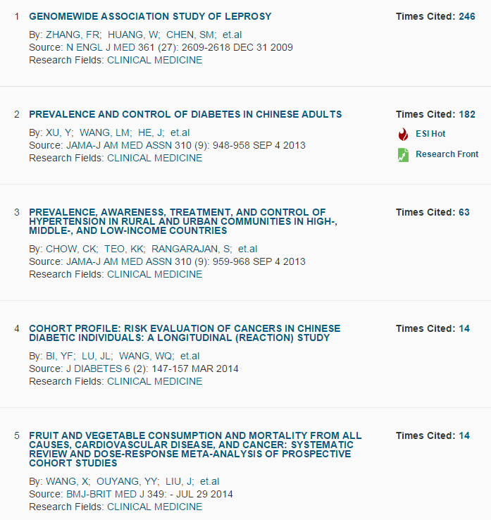

图-5 济南大学临床医学学科高被引论文

七、济南大学化学学科分析

化学2015年9月国内高校ESI排名如下表所示。可以看到排在前10位的科研机构分别是浙江大学、清华大学、南京大学、北京大学、复旦大学、中国科学技术大学、南开大学、吉林大学、华东理工大学和四川大学。在下表中，排名第一的浙江大学至排名第一百的河北师范大学，其化学学科都进入了ESI的前1%行列。我校的化学学科按照ESI总被引频次排在

表-5 ESI化学国内高校排名

|  |  |  |  |  |  |  |
| --- | --- | --- | --- | --- | --- | --- |
| 排名 | 机构名称 | 论文数量 | 学科相对影响力 | 总被引频次 | 论文被引用百分率 | 国际合作论文数 |
| 1 | Zhejiang University | 11582 | 1.1 | 145053 | 83 | 1574 |
| 2 | Tsinghua University | 8614 | 1.4 | 134699 | 83 | 1269 |
| 3 | Nanjing University | 8468 | 1.35 | 125635 | 84 | 1253 |
| 4 | Peking University | 7350 | 1.37 | 120120 | 85 | 1309 |
| 5 | Fudan University | 6456 | 1.43 | 115027 | 86 | 1110 |
| 6 | University of Science & Technology of China | 6810 | 1.43 | 107845 | 86 | 1057 |
| 7 | Nankai University | 7029 | 1.33 | 106383 | 85 | 711 |
| 8 | Jilin University | 9597 | 0.99 | 99072 | 79 | 1176 |
| 9 | East China University of Science & Technology | 6802 | 1.22 | 84532 | 82 | 1224 |
| 10 | Sichuan University | 7859 | 0.87 | 71392 | 78 | 741 |
| 11 | Wuhan University | 4523 | 1.38 | 70639 | 86 | 581 |
| 12 | Sun Yat Sen University | 4296 | 1.39 | 70299 | 84 | 636 |
| 13 | Dalian University of Technology | 4943 | 1.26 | 68165 | 82 | 972 |
| 14 | Xiamen University | 4676 | 1.33 | 67200 | 84 | 879 |
| 15 | Lanzhou University | 4685 | 1.31 | 60822 | 85 | 390 |
| 16 | Shandong University | 6232 | 0.92 | 59856 | 79 | 823 |
| 17 | Shanghai Jiao Tong University | 5000 | 1.06 | 59463 | 82 | 883 |
| 18 | South China University of Technology | 4911 | 1.16 | 53730 | 80 | 783 |
| 19 | Tianjin University | 6011 | 0.83 | 52245 | 75 | 708 |
| 20 | Northeast Normal University - China | 3471 | 1.22 | 50559 | 84 | 223 |
| 21 | Beijing University of Chemical Technology | 5051 | 0.95 | 49571 | 79 | 637 |
| 22 | Suzhou University | 4293 | 1.22 | 49438 | 82 | 643 |
| 23 | Hunan University | 3266 | 1.44 | 45479 | 84 | 382 |
| 24 | East China Normal University | 2752 | 1.38 | 36050 | 85 | 457 |
| 25 | Fuzhou University | 2771 | 1.38 | 33961 | 80 | 251 |
| 26 | Harbin Institute of Technology | 3263 | 0.99 | 29992 | 76 | 620 |
| 27 | Central China Normal University | 2171 | 1.17 | 28477 | 79 | 206 |
| 28 | Beijing Institute of Technology | 3146 | 0.86 | 27423 | 77 | 479 |
| 29 | Huazhong University of Science & Technology | 2752 | 1.09 | 26710 | 77 | 535 |
| 30 | Wuhan University of Technology | 1751 | 1.48 | 25956 | 79 | 396 |
| 31 | Southeast University - China | 3013 | 0.87 | 25658 | 72 | 361 |
| 32 | National Center for Nanoscience & Technology - China | 917 | 2.41 | 24798 | 88 | 188 |
| 33 | Zhengzhou University | 2990 | 0.89 | 23390 | 77 | 263 |
| 34 | Tongji University | 2271 | 1.06 | 23118 | 81 | 325 |
| 35 | Shanghai University | 2048 | 1.16 | 22047 | 79 | 265 |
| 36 | Donghua University | 2009 | 1.04 | 22006 | 81 | 362 |
| 37 | Beijing Normal University | 2221 | 0.93 | 21448 | 81 | 435 |
| 38 | Nanjing University of Technology | 3024 | 0.76 | 21126 | 72 | 330 |
| 39 | Northwest University Xi'an | 2485 | 0.84 | 20675 | 77 | 277 |
| 40 | Qingdao University of Science & Technology | 2485 | 0.84 | 20524 | 76 | 138 |
| 41 | Southwest University - China | 2090 | 1.11 | 20161 | 81 | 165 |
| 42 | Xi'an Jiaotong University | 2353 | 0.93 | 19993 | 75 | 437 |
| 43 | Central South University | 2939 | 0.78 | 19537 | 76 | 443 |
| 44 | Zhejiang University of Technology | 2687 | 0.68 | 19024 | 71 | 203 |
| 45 | Nanjing University of Science & Technology | 2225 | 0.89 | 17273 | 75 | 178 |
| 46 | Anhui Normal University | 1154 | 1.34 | 16426 | 85 | 55 |
| 47 | China Pharmaceutical University | 2118 | 0.7 | 15591 | 79 | 245 |
| 48 | University of Science & Technology Beijing | 1848 | 0.97 | 15212 | 77 | 303 |
| 49 | China University of Petroleum | 2095 | 0.79 | 14974 | 72 | 340 |
| 50 | South China Normal University | 1757 | 0.8 | 14527 | 78 | 366 |
| 51 | Henan Normal University | 1468 | 0.83 | 13024 | 78 | 129 |
| 52 | Jiangnan University | 1971 | 0.77 | 12999 | 73 | 301 |
| 53 | Shaanxi Normal University | 1729 | 0.77 | 12635 | 78 | 160 |
| 54 | Hunan Normal University | 938 | 1.17 | 12616 | 84 | 69 |
| 55 | Xiangtan University | 1379 | 1.04 | 12316 | 80 | 128 |
| 56 | China Agricultural University | 1819 | 0.59 | 11970 | 72 | 237 |
| 57 | Yangzhou University | 1302 | 0.9 | 11936 | 80 | 165 |
| 58 | Henan University | 1619 | 0.75 | 11777 | 77 | 117 |
| 59 | Jiangsu University | 1670 | 1.03 | 11578 | 72 | 193 |
| 60 | Shanghai Normal University | 792 | 1.37 | 11474 | 83 | 78 |
| 61 | Nanjing Normal University | 1039 | 1.11 | 11442 | 80 | 109 |
| 62 | Wenzhou University | 1130 | 0.93 | 10906 | 79 | 112 |
| 63 | Beihang University | 1265 | 0.96 | 10487 | 72 | 155 |
| 64 | Harbin Engineering University | 760 | 1.45 | 10410 | 76 | 103 |
| 65 | Hubei University | 896 | 1.01 | 10060 | 84 | 164 |
| **66** | **University of Jinan** | **1480** | **1.07** | **10057** | **72** | **129** |
| 67 | Ocean University of China | 1399 | 0.68 | 10005 | 75 | 141 |
| 68 | Nanchang University | 1376 | 0.9 | 9959 | 76 | 200 |
| 69 | Liaocheng University | 1686 | 0.49 | 9905 | 74 | 50 |
| 70 | Tianjin Normal University | 833 | 0.99 | 9820 | 74 | 33 |
| 71 | Chongqing University | 1658 | 0.84 | 9757 | 67 | 237 |
| 72 | Guangxi Normal University | 1106 | 0.81 | 9670 | 76 | 115 |
| 73 | Zhejiang Normal University | 1249 | 0.93 | 9446 | 77 | 125 |
| 74 | Shanxi University | 1188 | 0.88 | 9359 | 77 | 110 |
| 75 | Northeastern University - China | 1159 | 0.77 | 9356 | 75 | 178 |
| 76 | Shenyang Pharmaceutical University | 1330 | 0.58 | 9352 | 80 | 191 |
| 77 | Jinan University | 1330 | 0.69 | 9338 | 75 | 117 |
| 78 | Hebei University | 1466 | 0.57 | 9332 | 72 | 50 |
| 79 | Heilongjiang University | 1177 | 0.84 | 9237 | 78 | 202 |
| 80 | Shandong Normal University | 978 | 0.78 | 9048 | 79 | 71 |
| 81 | Hefei University of Technology | 1074 | 0.96 | 9027 | 72 | 140 |
| 82 | Nanjing University of Posts & Telecommunications | 544 | 1.68 | 8412 | 75 | 81 |
| 83 | Northwest Normal University - China | 1332 | 0.69 | 8344 | 77 | 62 |
| 84 | Beijing University of Technology | 996 | 0.85 | 8069 | 78 | 116 |
| 85 | Jiangsu Normal University | 1089 | 0.75 | 7934 | 73 | 54 |
| 86 | Northwestern Polytechnical University | 1196 | 0.78 | 7870 | 76 | 157 |
| 87 | Shantou University | 424 | 1.19 | 7618 | 85 | 63 |
| 88 | Anhui University | 964 | 0.85 | 7501 | 70 | 78 |
| 89 | Hangzhou Normal University | 850 | 1.11 | 7407 | 78 | 110 |
| 90 | Zhejiang Sci-Tech University | 832 | 1.11 | 7346 | 77 | 153 |
| 91 | Jiangxi Normal University | 848 | 1.23 | 7335 | 78 | 62 |
| 92 | Nanjing University of Aeronautics & Astronautics | 739 | 1.14 | 7329 | 75 | 129 |
| 93 | Liaoning Normal University | 1068 | 0.62 | 7224 | 78 | 51 |
| 94 | Huazhong Agricultural University | 667 | 0.95 | 6821 | 77 | 70 |
| 95 | China University of Geosciences | 991 | 0.86 | 6402 | 70 | 220 |
| 96 | Huaqiao University | 636 | 1.13 | 6394 | 80 | 39 |
| 97 | Yunnan University | 893 | 0.69 | 6196 | 76 | 71 |
| 98 | Second Military Medical University | 826 | 0.67 | 6093 | 80 | 84 |
| 99 | Capital Normal University | 932 | 0.71 | 6015 | 75 | 62 |
| 100 | Hebei Normal University | 718 | 0.76 | 5932 | 78 | 56 |

我校化学共有6篇高被引论文，如下图所示：

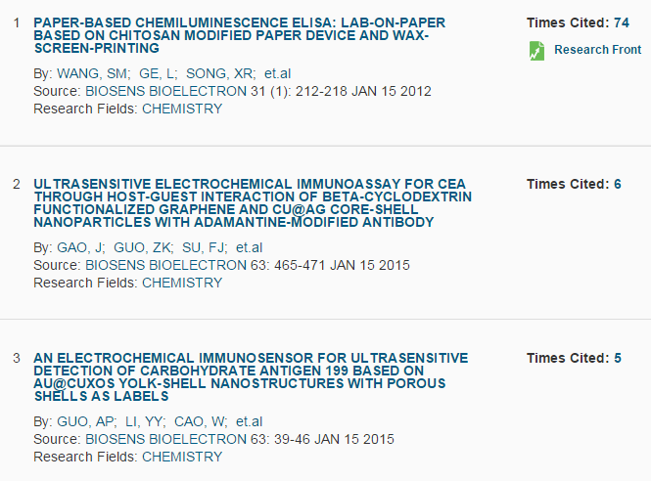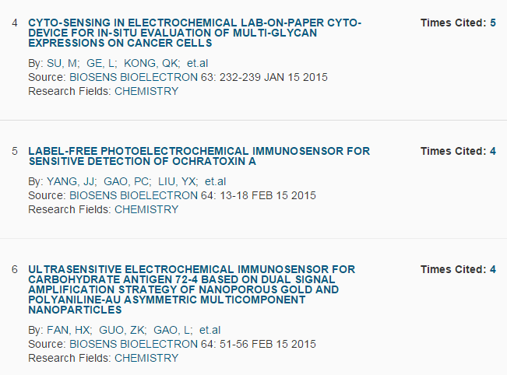

图-6 济南大学化学学科高被引论文

1. 门槛值，即在各ESI学科中，最后一个进入该学科的机构的总被引频次。